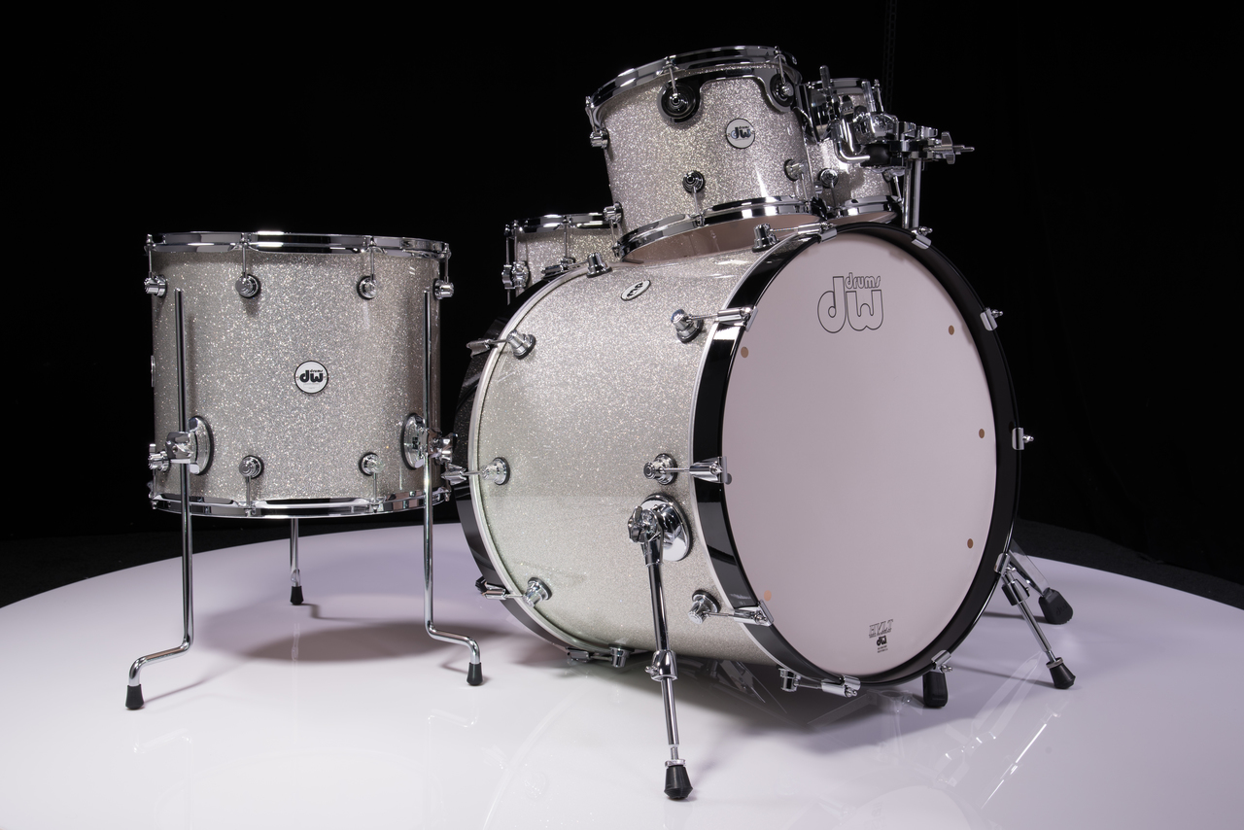

Introduction to Engineering Design

Automated Drum Tuner

Kaleb Golden | EG325 | 4/29/19

# 1. Introduction

Tuning drums, the bane of almost every drummer in the industry. It can be a long and arduous process takes precious time that could be used for practicing instead of sitting there turning a drum key. The problem in question is, how can I tune my drums without having to take time to do it? The answer is simple, an automated drum tuner. I first became interested in this idea for an automated drum tuning system when I was playing in church one Sunday and spent a good 10-15 minutes tuning the drums to get my preferred sound from them. I realized that if there was a system that could do it for me, I could’ve spent that time rehearsing with the rest of the band and been more prepared for the set. This is when I realized that I simply can’t be the only drummer who has thought this before and so I began putting some serious time and effort into researching this idea. There have been ideas for drums that come pre-tuned and then tend to stay tuned for longer, but they were unsuccessful because they were made with cheap materials and affected the tone of the drums significantly. There are also several products that can detect the frequency of the drum head at specific points which then allow you to be able to tune every lug to that exact frequency. These are every helpful but still require you to spend time tuning your drums by hand. There are “automated” tuners out there, but you can’t play the drum while they are attached to it because they rest on top of the drum and obstruct the batter head. The automated drum tuner I am proposing to create hasn’t been patented or published anywhere so it may be the first of its kind. It will be a fully integrated system in which there is a frequency sensor, processing unit, and several motors to be able to automatically detect and change the tuning of your drum as needed. The system will be attached directly to the drum and be compact enough so that it does not interfere with drum and hardware spacings. I know that this product would be fantastic not only for beginners who are just learning drums but also professionals who play drums daily for a living. By the end of this project I expect to have fully integrated the system into a single drum with at least 6 motors (Price depending and drum size depending), to where it can detect the frequency of the drum once struck and be able to automatically adjust the tuning rods as needed to obtain a frequency desired plus or minus a few Hertz.

## 2. Prior art

There are several systems that are attempting to solve the problem at hand but each falling short of what the ATD is attempting to accomplish. There are a few patented systems that are shown with short descriptions of their operations shown below. The main difference between the ATD and any automatic drum tuners that are on the market currently is that the ATD will be able to autonomously tune the drum even while it is being used for playing. The ATD will also utilize a frequency sensor while some of the other systems utilize vibration sensors to detect changes. The integrated system will allow the drum to be essentially hands free when the system is powered on besides when it is being struck.

Active Patent List:

**US8283544B2:**

“An automatic membrane tension adjustment system for a membrane whose surface tension is adjusted using tension rods, said system comprising:

1. tension rod adjustment members that are configured to releasably join with tension rods and rotate the tension rods;
2. motors joined with said tension rod adjustment members, said motors configured to automatically rotate said tension rod adjustment members;
3. vibration sensors, each of which is configured to be positioned on a membrane to measure a vibration frequency at a position on the membrane;
4. an automatic excitation member configured to cause a membrane to resonate; and
5. A control module for controlling said automatic excitation member and said motors based on data received from said vibration sensors.”

**US8772617B1:**

“A drum tuner is described. The drum tuner includes: (i) a hub gear; (ii) two or more differential gears communicatively coupled to the hub gear and at least one of the two or more differential gears capable of engaging a tuning mechanism of a drum; and (iii) wherein, during an operational state of the drum tuner, rotation of the hub gear rotates at least one of the two or more differential gears to activate the drum's tuning mechanism.”

**US8759655B2:**

“Provided are systems and methods for resonance tuning. A signal is received in response to a resonance of a structure. A frequency or musical note related to an overtone is determined from the signal. The frequency or musical note related to the overtone is selected as a filter mode reference frequency or musical note. A display of frequencies or musical notes from a subsequent signal that deviate from the filter mode reference frequency or musical note by a predetermined threshold is suppressed.”

Abandoned Patent List:

**US20120240749A1:**

“An instrument tuner for drums that has a sensing means for sensing the combined fundamental resonance and pitch from inside the drum; a measurement means for measuring a frequency of said combined fundamental resonance and pitch; and a selection means to then compare the frequency measured to a corresponding musical note of the instrument tuner. Even though the sensing means will be internal to the drum, the tuner or display could be external to the drum and/or separate from the sensing means; a wireless device or system is specified also that could be used with this method. A single-note tuner is specified, as well as a tuner designed to recognize more than a single-note, if a wireless device or system is used, as one example, for a complete drum set.”

## 3. concept of operation (conops)

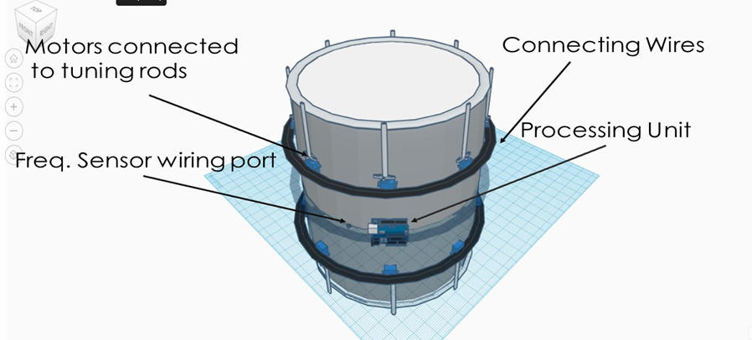

The above photograph shows an approximate representation of the system in question, it shows the usage of motors, a processing unit, and a frequency sensor to both monitor and be able to tune the drum according to a set frequency value.

## 4. requirements definition

The system shall [1] constantly and automatically monitor its tuning.

Drum shall [1.1] have a frequency sensor.

Drum shall [1.2] have a processing unit.

Drum shall [1.3] have motors to turn the tuning rods.

The frequency sensor shall [2] be able to constantly monitor the frequency of the drum when struck.

The sensor shall [2.1] be mounted on the inside of the drum.

The sensor shall [2.2] be connected to the processing unit.

The sensor shall [2.3] output the frequency value to the processing unit.

The processing unit shall [3] be able to convert frequency to voltage.

The processing unit shall [3.1] have a frequency to voltage converting chip.

The processing unit shall [3.2] be able to control the motors with voltages.

The processing unit shall [3.3] obtain the frequency value through the frequency sensor.

The motors shall [4] be mounted on the sides of the drum and attached to the tuning rods.

The motors shall [4.1] be attached to the threaded tuning rods.

The motors shall [4.2] be able to turn both directions to tighten and loosen the tuning rods.

The motors shall [4.3] be able to run on less than 15 volts.

5. REQUIREMENTS TRACEABILITY MATRIX

|  |  |  |  |
| --- | --- | --- | --- |
| Requirement # | Verification Method | Justification | Other |
| Autonomously monitor the drums tuning [1] | Analysis | After checking that the rest of the systems work both individually and in unison, confirm that the drum automatically monitors the drums tuning and can change it if needed. | N/A |
| Frequency Sensor [1.1] | Inspection | Visually examine to see if the product has a frequency sensor. | N/A |
| Processing Unit1.2] | Inspection | Visually examine to see if the product has a processing unit. | N/A |
| Motors [1.3] | Inspection | Visually examine to see if the product has motors. | N/A |
| Frequency sensor monitors frequency when struck [2] | Demonstration | Confirm that the sensor is reading values by using a DMM to make sure the y | N/A |
| Sensor mounted on the inside of the drum [2.1] | Inspection | Visually examine to see if the product has a frequency sensor mounted on the interior of the drum. | N/A |
| Sensor connected to the processing unit [2.2] | Inspection | Visually examine to see if the product has a frequency sensor that is connected to the processing unit through wires. | N/A |
| Sensor outputs the frequency value to the processing unit [2.3] | Test | Connect the frequency sensor to the processing unit and have the unit output the value received from the sensor. | N/A |
| Processing unit converts frequency to voltage [3] | Demonstration | Using a DMM show that they are processing unit can convert frequency to voltage. | N/A |
| Processing Unit has frequency to voltage converting program [3.1] | Analysis | With the frequency sensor and motors connected to the processing unit confirm that the program in question successfully converts frequency to voltage. | N/A |
| Processing unit can control the motors with voltages [3.2] | Demonstration | Show that the processing unit can convert voltages and output them to the motors successfully. | N/A |
| Processing unit shall obtain the frequency value from the frequency sensor [3.3] | Test | Confirm that the processing unit receives the frequency value through using the program. | N/A |
| Motors mounted on the sides of the drum attached to the tuning rods [4] | Inspection | Visually examine to see if the motors are mounted to the sides of the drum and attached to the tuning rods. | N/A |
| Motors be attached to the threaded tuning rods [4.1] | Inspection | Visually examine to see if the motors are attached to the threaded tuning rods and confirm that they can spin freely. | N/A |
| Motors able to turn in both directions to tighten and loosen the tuning rods [4.2] | Demonstration | Power the motor and confirm it can move both clockwise and counterclockwise while attached to the tuning rods. | N/A |
| Motors shall run on less than 15 volts [4.3] | Test | Output voltages less than 15 volts to the motors and confirm that they can move clockwise and counterclockwise with the given voltages. | N/A |

## 6. architecture:

CONOPS Photo:

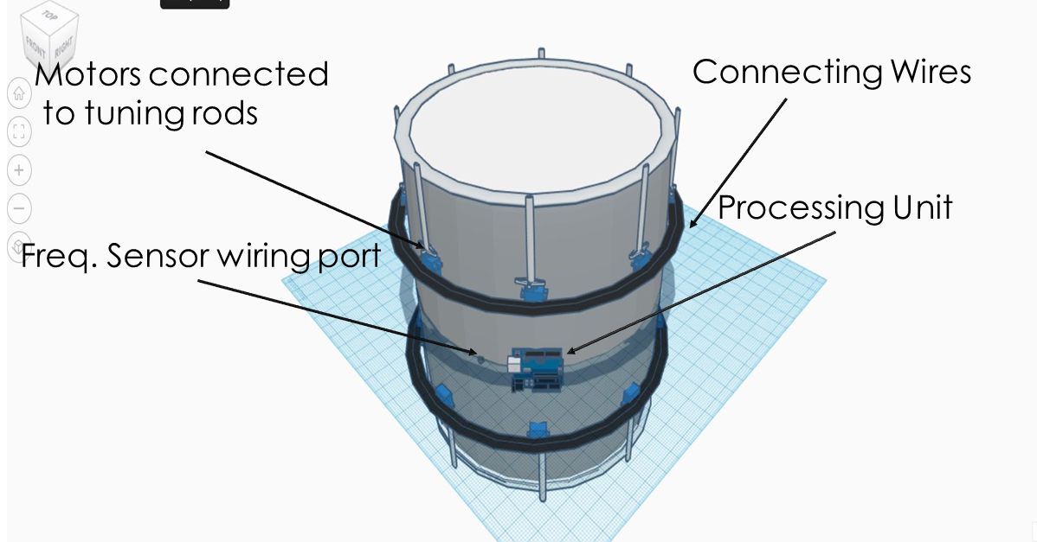

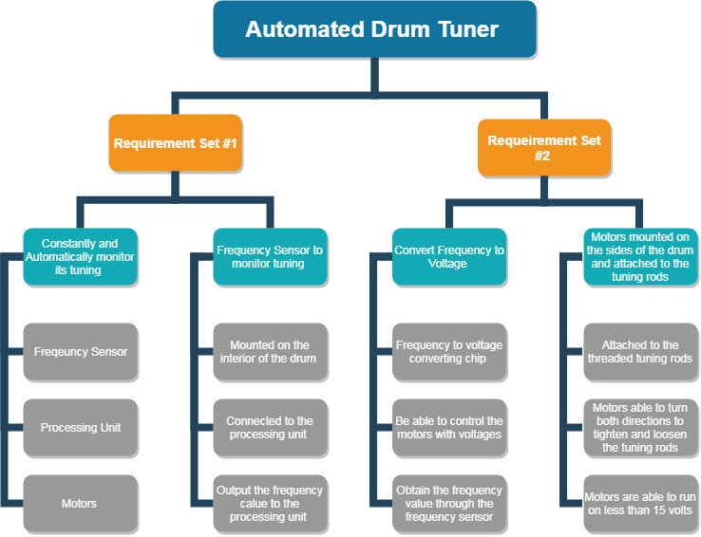

## 7. Basis of estimate (BOE)

Hardware list: Cost:

1. Arduino Zero Board $43
2. Electret Microphone chip $7
3. Wires Provided
4. Capacitor Provided
5. Potentiometer Provided
6. Resistors Provided
7. Types of motors needed is still to be determined.

DESIGN and INTEGRATION is going to be used in this system as many of the components being utilized are already created and ready to be used. There are several links shown below that lead to some of the parts being utilized in this system.

<https://www.arduino.cc/en/Tutorial/SimpleAudioFrequencyMeter> Possible Arduino solution to find frequency (60Hz-1500Hz).

<https://store.arduino.cc/usa/arduino-zero> Arduino Zero board.

<https://www.adafruit.com/product/1063> Microphone for frequency sensor.

## 8. Timeline to completion

Provide an original timeline estimate that you think will satisfy the implementation of your design. The timeline could use the following format

|  |  |  |
| --- | --- | --- |
| List of Tasks | Date | Justification |
| 1. Order required parts | Week of Sept. 1st | Place the order for the required parts |
| 2. Build frequency to voltage circuit | Week of Sept. 9th | Spend this week building the circuit for the frequency to voltage converter |
| 3. Voltage to motor rotate conversion | Week of Sept. 16th | Spend this week completing the required math and calculations for the necessary amount of turns to properly tune one tuning rod using a motor |
| 4. Cont. prior week | Week of Sept. 23rd | Continue prior week’s work |
| 5. Confirm circuit and program | Week of Sept. 30th | Combine the circuit and the program together to confirm that the motor will work with the hardware and software aspects |
| 6. Confirm prior controls motor | Week of Oct. 7th | Confirm prior weeks work and continue fine tuning the number of turns for the motor for precision |
| 7. Rework week (if needed) | Week of Oct. 14th | Spend this week reworking any hardware or software bugs including wiring issues or bugs |
| 8. Add 2 motors to sequence (Price Dependent) | Week of Oct. 21st | Add two motors to the project and confirm that the program will work with three motors |
| 9. Rework program (if needed) | Week of Oct. 28th | Rework the program or hardware if needed to adjust for three motors |
| 10. Add 2 motors to sequence (Price Dependent) | Week of Nov. 4th | Add two motors to the project and confirm that the program will work with five motors |
| 11. Rework program (If needed) | Week of Nov. 11th | Rework the program or hardware if needed to adjust for five motors |
| 12. Add final motor (6 total, Price Dependent) | Week of Nov. 18th | Add final motor to the project and confirm that the program will work with all six motors |
| 13. Confirm system operational | Week of Nov. 25th | Confirm that the full six motor system can automatically monitor drum frequency and adjust it based on a range of frequencies |
| 14. Attach hardware to drum | Week of Dec. 2nd | Attach the full system to the drum in such a way that it is not cumbersome to the drum itself |
| 15. Confirm system tunes drum | Week of Dec. 9th | Once again confirm the system can tune the drum accordingly while integrated on the drum |
| 16 Final rework and presentation | Week of Dec.16th | Spend this week reworking any last-minute details and begin preparations to present the product! |

## 9. conclusions

Link to roadmap given below.

<https://infograph.venngage.com/ps/rRZkwanrows/light-vertical-product-launch-roadmap_new>